

CP Lab-05 Tasks

Name: Syed Muhammad Raza Ali

Enrolment: 02-134231-028

Course: CP Lab

Faculty: Miss Fatima

**Lab 05**

**Tasks: 01**

Write a C program to convert an array into ascending order.

Code:

#include <iOStream>

using namespace std;

int main() {

int arr[5];

int i;

for (i = 0; i < 5; i++) {

cout << "Enter the value of index no: " << i << endl;

cin >> arr[i];

}

cout << "Elements of original array = ";

for (int j = 0; j < 5; j++) {

cout << arr[j] << " , ";

}

int temp;

for (int l = 0; l < 5; l++) {

for (int k = 0; k < 5-1; k++) {

if (arr[k] > arr[k + 1]) {

temp = arr[k];

arr[k] = arr[k + 1];

arr[k + 1] = temp;

}

}

}

cout << endl;

cout << "Elements of Array in ascending order = ";

for (int m = 0; m < 5; m++) {

cout << arr[m] << " , ";

}

return 0;

}

Output:

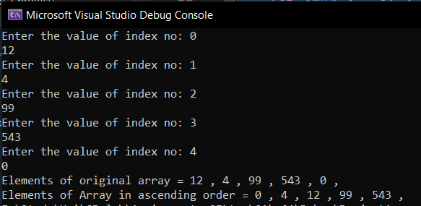

**Tasks: 02**

Write a C program to search an element entered by user from array and display the searched element and its location.

Code:

#include <iostream>

using namespace std;

int main() {

int arr[100], n, search_element, location = -1;

cout << "Enter the number of elements in array: ";

cin >> n;

cout << "Enter " << n << " integers:" << endl;

for (int i = 0; i < n; i++) {

cin >> arr[i];

}

cout << "Enter the element to be searched: ";

cin >> search_element;

for (int i = 0; i < n; i++) {

if (arr[i] == search_element) {

location = i;

break;

}

}

if (location == -1) {

cout << "Element not found in the array." << endl;

}

else {

cout << "Element found at index " << location << " in the array." << endl;

}

return 0;

}

Output 1:

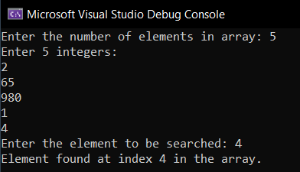

Output 2:

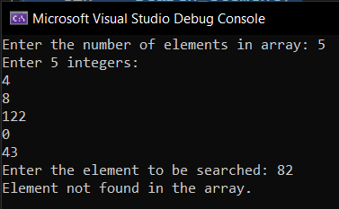

**Tasks: 03**

Write a C++ program to find total number of elements in an array and print number of elements repeated in an array also print all unique elements in an array.

Code:

#include <iostream>

using namespace std;

int main()

{

int n;

cout << "Enter the size of the array: ";

cin >> n;

int arr[100];

for (int i = 0; i < n; i++)

{

cout << "Enter the elements of the array: ";

cin >> arr[i];

}

int repeat = 0;

int unique[10];

int uCount = 0;

bool isUnique;

for (int i = 0; i < n; i++)

{

isUnique = true;

for (int j = i + 1; j < n; j++)

{

if (arr[i] == arr[j])

{

repeat++;

isUnique = false;

break;

}

}

if (isUnique)

{

unique[uCount] = arr[i];

uCount++;

}

}

cout << "Total number of elements in the array: " << n << endl;

cout << "Number of repeated elements in the array: " << repeat << endl;

cout << "Unique elements in the array: ";

for (int i = 0; i < uCount; i++)

{

cout << unique[i] << " ";

}

cout << endl;

return 0;

}

Output:

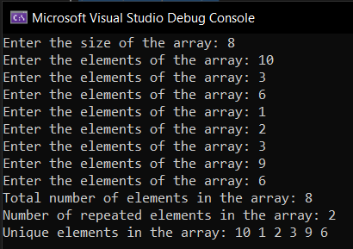

**Tasks: 04**

Write a program in C++ to identify array in which no zero present, and print those numbers. If user input a value without zero program should terminate.

Code:

#include <iOStream>

using namespace std;

int main() {

int arr[100], n;

cout << "Enter the number of elements of array: ";

cin >> n;

int i;

for ( i = 0; i < n; i++) {

cout << "Enter the element of index no " << i << " : ";

cin >> arr[i];

if (arr[i] == 0) {

cout << "Program terminated because you enetered 0";

break;

}

}

cout << endl;

int updated_n = i;

cout << "Array of the entered elements = ";

for (int l = 0; l < i; l++) {

cout << arr[l] << " ";

}

return 0;

}

Output 1:

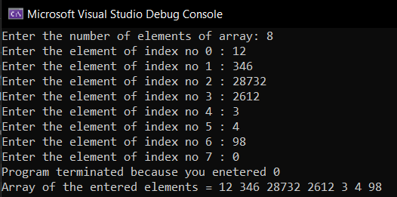

Output 2:

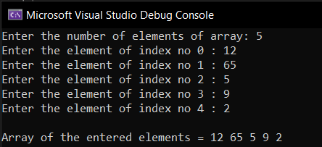

**Tasks: 05**

Write a C++ program that asks user to enter 10 integer values. Store those values in one dimensional array. Create another one-dimensional array of same size, and store the values of first array in reverse order. Print the result on Screen.

Code:

#include <iOStream>

using namespace std;

int main() {

int arr[10];

for (int i = 0; i < 10; i++) {

cout << "Enter the value of index no: " << i << " : ";

cin >> arr[i];

}

cout << endl << "Original array = ";

for (int i = 0; i < 10; i++) {

cout << arr[i] << " ";

}

cout << endl << "Reversed array = ";

for (int i = 9

; i > 0; i--) {

cout << arr[i] << " ";

}

return 0;

}

Output:

